Concept：Art & History Tour

User :

1) the elderly

2) live alone (no friends can tell them the latest information about museum and gallery)

3) enthusiastic with art and history

4) has difficulty to use social media to get information like other young people

Motivation:

in the face of art and history, everyone should be equal, no matter young or old. We want to help more elderly people, enrich their lives and make them less lonely!

Core Function:

1. Notification ---- **Interaction 1**

Introduction: the elderly can know the latest information about galleries.

Dataset: [Townsville City Council Arts and Culture - Galleries | Datasets | data.gov.au - beta](https://data.gov.au/dataset/ds-dga-e2e8a37c-e7c5-4ede-8860-be7807446bff/details?q=gallery%20exhibition)

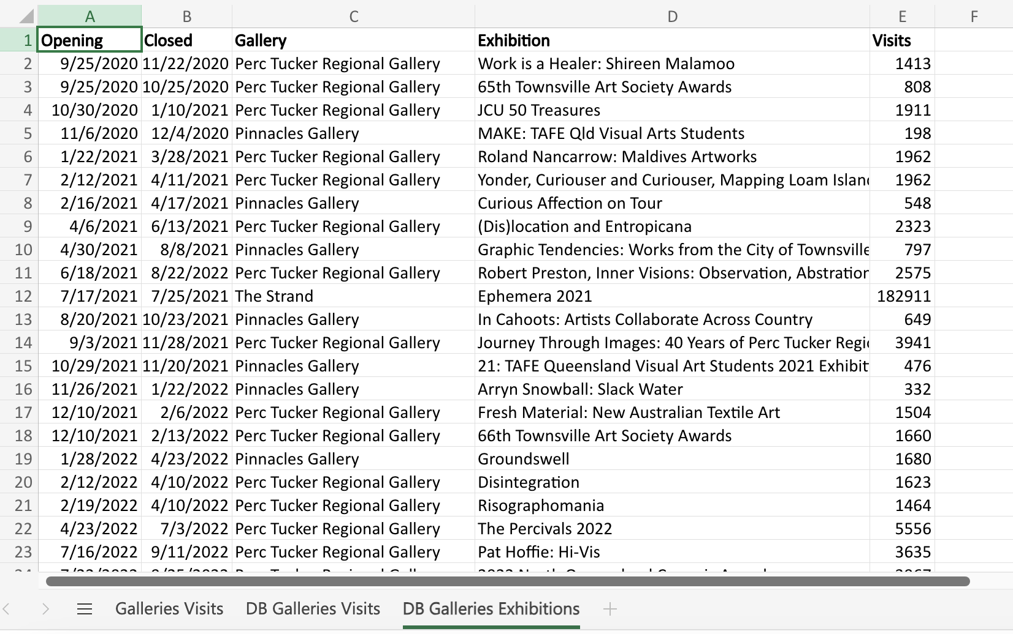

[Events — Museum of Brisbane | Datasets | data.gov.au - beta](https://data.gov.au/dataset/ds-brisbane-a8c635aa-c0f3-47ce-b455-eb4cef3e1e64/details?q=museum) (Last update in 2022, not recommend.)

1. Map ---- **Interaction 2**

Introduction: get the location of recent gallery and museum.

Dataset: [Public Art Collection — Explore our Open Data | Brisbane City Council](https://data.brisbane.qld.gov.au/explore/dataset/public-art/map/?disjunctive.item_title&disjunctive.the_location&disjunctive.material&disjunctive.suburb&dataChart=%3D&location=12,-27.45354,153.03474&basemap=jawg.streets)

1. Weather condition ---- **Interaction 3**

Introduction : if user prepare to go the destination, they need to know the weather.

API : [🌦️ Docs | Open-Meteo.com](https://open-meteo.com/en/docs)